Name: Callejo, Jaff Raine Jay V. Date Submitted: October 30, 2025
Course, Year and Section: BSIT – 2A Subject: Platform Technologies

Lesson 3 – Assessment 3 (Laboratory Activity):
Alison Course Completion + Cloud Service Simulation
Activity Title:
Google Cloud Computing Foundation + Cloud Deployment Simulation

Objective:
To develop foundational knowledge and hands-on familiarity with Google Cloud concepts, architecture, and services by completing the Google Cloud Computing Foundation course and performing a short simulation of deploying or managing cloud resources.
This activity enhances cloud literacy, problem-solving, and documentation skills—essential for IT and software-related roles.

Course Link:
https://alison.com/course/google-cloud-computing-foundation

Instructions
Part 1 – Complete the Alison Course
Step 1. Alison Dashboard showing 100% completion
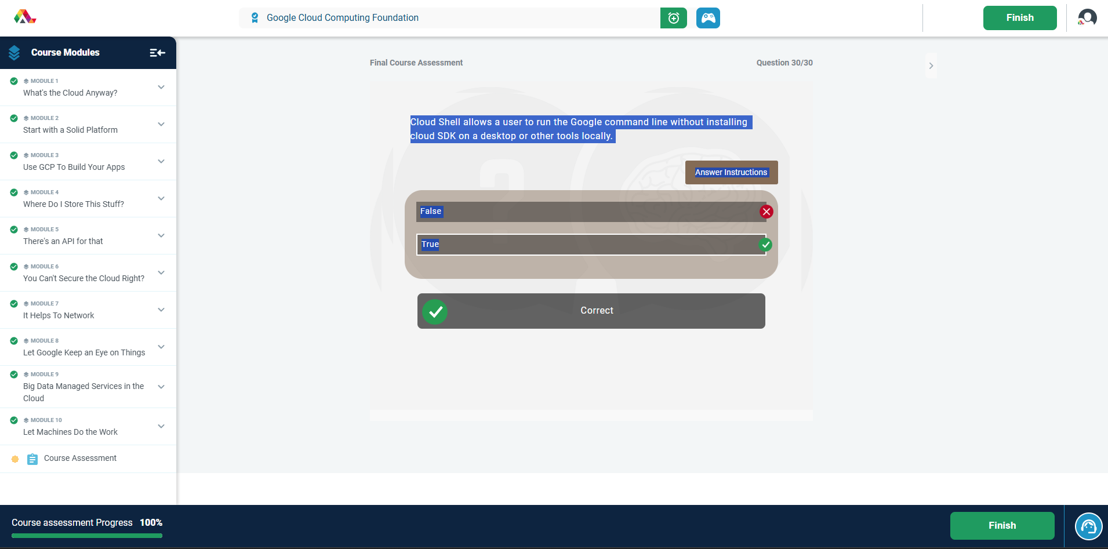
Step 2. Assessment Results or Progress Page (with quiz scores)
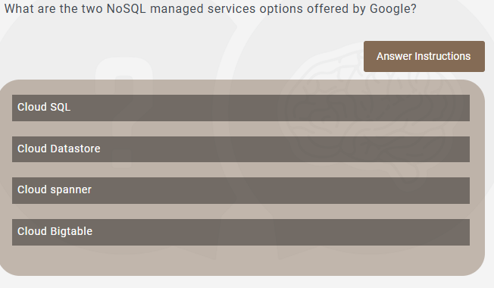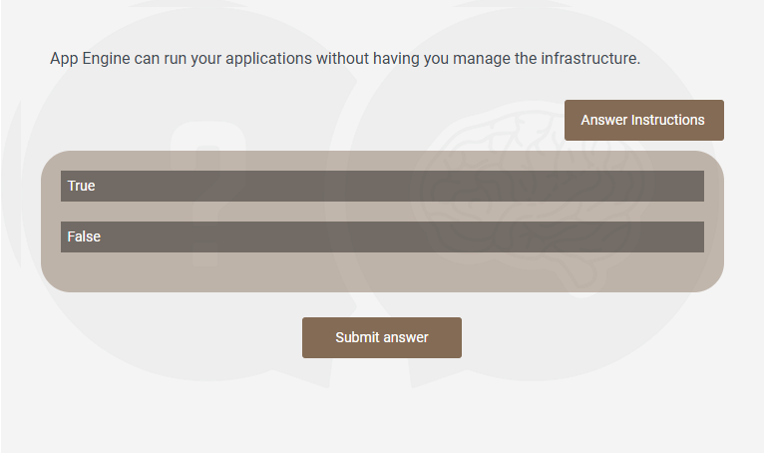

Step 3. Certificate of Completion (PDF or screenshot)

Part 2 – Cloud Service Simulation

Simulation: Deploying a Web Application using Google Compute Engine (GCE)
Objective:
To deploy a simple web server on Google Cloud so it can be accessed online.

Steps
- Log in to Google Cloud Console
  - Open Google Cloud Console and sign in.

- Open Compute Engine
  - From the menu (☰), select Compute Engine → VM Instances → Create Instance.

- Configure the Virtual Machine (VM)
  - Name: e.g., my-web-server
  - Region & Zone: e.g., us-central1
  - Machine Type: e2-micro (free-tier friendly)
  - Boot Disk: Debian Linux or Ubuntu
- Set Firewall Rules
  - Check Allow HTTP traffic
  - Check Allow HTTPS traffic

- Create VM
  - Click Create and wait for the VM to be ready.

- Connect via SSH
  - Click SSH next to your VM to open the terminal.

- Install Web Server
  - Run these commands:
  - sudo apt update
  - sudo apt install apache2 –y

- Verify Deployment
  - Copy the External IP of your VM.
  - Paste it in a browser. You should see the Apache welcome page.

Summary
This simulation demonstrates how to deploy a web application using Google Compute Engine. Key tasks include creating a VM, configuring firewall rules, connecting via SSH, and installing a web server. Understanding these steps helps manage cloud resources professionally and is essential for IT and software development roles.

Write one (1) of the following:
- A step-by-step guide simulating how to create or deploy a cloud resource (e.g., a virtual machine, storage bucket, or app).
OR
- A scenario-based response simulating cloud troubleshooting or management (e.g., fixing permission errors, cost issues, or connectivity problems).
Choose ONE sample scenario below:
- Deploying a web application using Compute Engine
- Uploading and sharing data using Cloud Storage
- Troubleshooting a permission issue in IAM
- Monitoring performance using Cloud Console
- Cost optimization using billing reports
Include:
- Proper steps or troubleshooting flow
- Technical terms and clear explanation
- Professional and concise documentation style
Place your simulation after your reflection section.

Screenshot Requirements and Placement
Screenshot No. | Description | Placement
1 | Alison Dashboard showing 100% completion | After Step 3
2 | Assessment Results or Progress Page (with quiz scores) | After Step 4
3 | Certificate of Completion (PDF or screenshot) | After Step 5
4 (Optional) | Module/page you found most insightful (with 1-line caption) | In Reflection Section
All screenshots must be clear, uncropped, and show your name/username when possible.

Submission Format
Submit a single Word or PDF file that includes:
- All required screenshots
- Your Reflection (200–300 words)
- Your Cloud Service Simulation (guide or scenario)
- Your Certificate of Completion or Assessment Score
Filename format:
Lastname_Firstname_GCloud_Activity3

Reflection Guide (200–300 words)
In your own words:
- What were the most valuable things you learned from the course?
  - During this course, I learned the basic principles of cloud computing and how cloud services work. I understood how Google Cloud helps manage infrastructure, data, and applications efficiently. One of the most important lessons was the shared responsibility model, which explains how both the provider and user are responsible for security and management. I also learned how different tools, like Compute Engine, Cloud Storage, and BigQuery, work together to support applications and store data. This helped me see how cloud services are connected and why they are important for businesses. Learning about virtual machines, storage solutions, and databases gave me practical knowledge I can use in real projects. I also discovered how cloud services can save time and improve performance compared to traditional systems. Overall, this course gave me a solid foundation in understanding cloud architecture and services. It helped me feel confident about using cloud tools and prepared me for more advanced topics in cloud computing.
- Which Google Cloud tools or topics stood out most?
  - The Google Cloud tools that stood out most to me were Compute Engine and IAM (Identity and Access Management). Compute Engine is important because it allows users to create and scale virtual machines quickly, which is useful for running applications or testing software. IAM was also very useful because it shows how to manage access and permissions for different users, keeping resources secure. I also liked Cloud Storage because it lets you upload, store, and share files easily. BigQuery was interesting because it allows fast analysis of large datasets. These tools are very practical and show how real-world applications run on the cloud. Learning about these tools helped me understand the workflow of cloud systems and how developers and IT professionals use them to build and manage projects. Overall, the hands-on lessons with these tools made the concepts easier to understand and more engaging.
- What challenges did you face (if any)?
  - One challenge I faced was understanding Google Cloud’s billing and cost management. At first, it was confusing to see how resources like virtual machines, storage, and data processing are charged. I also found it a little difficult to follow some of the technical terms when learning about IAM and permissions. However, by reviewing the modules and going through the examples again, I understood how to estimate costs and manage spending using Google’s pricing tools. Another challenge was remembering the steps to create and manage virtual machines in Compute Engine, but repeated practice helped me gain confidence. Overall, the challenges were minor and mostly involved understanding technical details. They helped me learn more deeply because I had to review and practice to fully grasp the concepts. Facing these challenges also made me realize the importance of reading instructions carefully and exploring cloud tools hands-on.

- How will this knowledge help in your future IT or software development career?
  - This course will help me a lot in my future IT or software development career. Learning how to use Google Cloud tools like Compute Engine, Cloud Storage, BigQuery, and IAM gives me skills that are in high demand. I now know how to deploy applications, manage cloud resources, and secure data in a professional environment. Understanding cloud architecture and services will allow me to work efficiently in companies that rely on cloud infrastructure. The knowledge of cost management and monitoring will also help me make better decisions when managing cloud projects. This course improved both my technical understanding and my confidence in using cloud tools. By practicing these tools, I feel prepared to handle real-world IT tasks, such as troubleshooting, deploying web apps, and analyzing data in the cloud. Overall, the course gave me a strong foundation for a career in IT, software development, or cloud computing, and it motivates me to learn more advanced cloud technologies in the future.

Rubric – Total: 100 Points
Criteria | Excellent (16–20 pts) | Very Good (11–15 pts) | Good (6–10 pts) | Needs Improvement (1–5 pts) | Poor (0 pts) | Score
1. Course Completion | Completed with certificate; all modules finished with high scores | Completed; cert shown with minor issues | Completed but unclear details | Incomplete; missing cert | No attempt
2. Screenshot Documentation | All required screenshots attached, clear and visible | Minor screenshots missing or unclear | Some blurry or missing details | Screenshots cropped or unreadable | None
3. Reflection Quality | Deep insight, thoughtful, and articulate | Clear and relevant with good depth | Basic ideas, surface-level | Very short or vague | None
4. Cloud Simulation | Clear, realistic, and technically accurate | Mostly clear, logical, professional | Limited realism or minor technical errors | Unclear or incorrect flow | Not submitted
5. Timeliness | Submitted on/before deadline | 1–2 days late | 3–5 days late | 6+ days late | Not submitted
Total Score: ___________

